Form CM 9A
REPUBLIC OF NAMIBIA

BUSINESS AND INTELLECTUAL PROPERTY AUTHORITY - BIPA
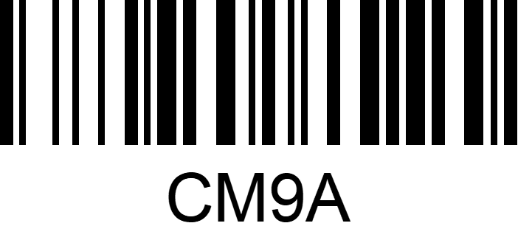
COMPANIES ACT 2004
(Section 50(2)) (Regulation 16(2))

(to be lodged in duplicate)

CERTIFICATE OF CHANGE OF SHORTENED FORM OF NAME OF COMPANY
Registration Number of Company

Name of Company

This is to certify that the Company has changed the former shortened form of its name from:

to:

and that the new shortened form of its name has this day been registered.

Signed and sealed at WINDHOEK this _______ day of ___________________________ of the year _______

_____________________________
Registrar of Business

Seal of Business Registration Office

This certificate is not valid unless sealed by the Seal of Business Registration Office
Continuation of Form CM 9A
REPUBLIC OF NAMIBIA

BUSINESS AND INTELLECTUAL PROPERTY AUTHORITY - BIPA

COMPANIES ACT 2004
(Section 50(2)) (Regulation 16 (2))

APPLICATION FOR CHANGE OF SHORTENED FORM OF NAME OF COMPANY
Registration Number of Company

N$ 120,00 fee payable in terms of the Act and as set out in the regulations

Name of Company

Consequent upon the change of the name of the company by Special Resolution, dated

___________________________

the former shortened form of the name of the company no longer applies to the company and has been changed
from

to

If changed shortened form of name of company is not in official language, provide translation thereof in as far as possible

Date _______________________________ Signature ________________________________
Director/ Manager/ Secretary
Postal address _______________________________
_______________________________
_______________________________

Perforated (To be completed by company)

Certificate of change of shortened form of name of company, dated _________________________________

Name of Company
Postal address |  |  |  |  | Registrar of Business
 |  |  |  |  | Date stamp of Business
Email address: |  |  |  |  | Registration Office

