REPUBLIC OF NAMIBIA Form CM 44C

BUSINESS AND INTELLECTUAL PROPERTY AUTHORITY - BIPA
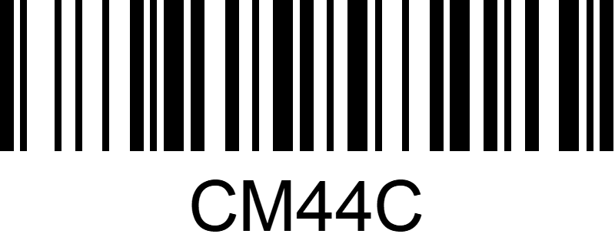
COMPANIES ACT 2004
(Section 64) (Regulation 18 (1), (2) and (3))

SIGNATORIES TO ARTICLES OF ASSOCIATION

Particulars of subscriber | Date and signature  of subscriber | Particulars of witness | Date and signature  of witness
1. Full names |  | 1. Full names
Occupation |  | Occupation
Residential address |  | Residential address
Business address |  | Business address
Postal address |  | Postal address
2. Full names |  | 2. Full names
Occupation |  | Occupation
Residential address |  | Residential address
Business address |  | Business address
Postal address |  | Postal address
3. Full names |  | 3. Full names
Occupation |  | Occupation
Residential address |  | Residential address
Business address |  | Business address
Postal address |  | Postal address
4. Full names |  | 4. Full names
Occupation |  | Occupation
Residential address |  | Residential address
Business address |  | Business address
Postal address |  | Postal address

continuation of Form CM 44C

SIGNATORIES TO ARTICLES OF ASSOCIATION

Particulars of subscriber | Date and signature  of subscriber | Particulars of witness | Date and signature  of witness
5. Full Names  Occupation  Residential address  Business address  Postal address |  | 5. Full Names  Occupation  Residential address  Business address  Postal address
6. Full Names  Occupation |  | 6. Full Names  Occupation
Residential address |  | Residential address
Business address |  | Business address
Postal address |  | Postal address
7. Full names |  | 7. Full names
Occupation |  | Occupation
Residential address  Business address  Postal address |  | Residential address  Business address  Postal address

