Form CM 44B
REPUBLIC OF NAMIBIA

BUSINESS AND INTELLECTUAL PROPERTY AUTHORITY - BIPA
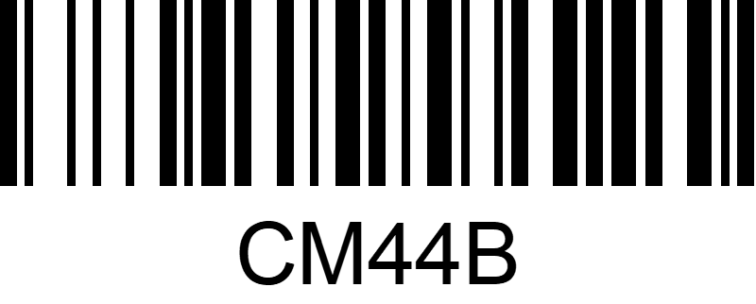
COMPANIES ACT 2004
(Section 64) (Regulation 18(3))

ARTICLES OF ASSOCIATION OF A COMPANY NOT HAVING SHARE CAPITAL NOT ADOPTING SCHEDULE 1
Registration Number of Company

NAME OF COMPANY:

............................................................................................................................................

A. The articles of Table A contained in Schedule 1 to the Companies Act, 2004, shall not apply to the Company.

B. The articles of the company are as follows:

