Form CM 44A
REPUBLIC OF NAMIBIA

BUSINESS AND INTELLECTUAL PROPERTY AUTHORITY - BIPA
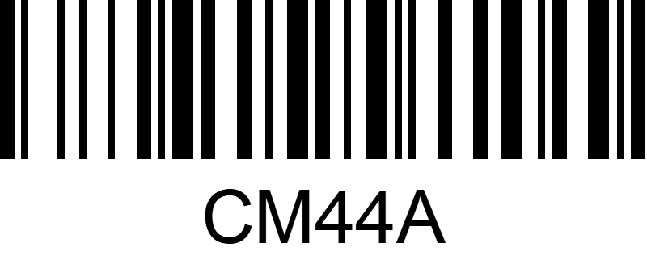
COMPANIES ACT 2004
(Section 64) (Regulation 18(2))

ARTICLES OF ASSOCIATION
OF A COMPANY HAVING A SHARE CAPITAL
NOT ADOPTING SCHEDULE 1
Registration Number of Company

NAME OF COMPANY:

............................................................................................................................................

A. The articles of Table B contained in Schedule 1 to the Companies Act, 2004, shall not apply to the Company.

B. The articles of the company are as follows:

