Form CM 28
REPUBLIC OF NAMIBIA

BUSINESS AND INTELLECTUAL PROPERTY AUTHORITY - BIPA
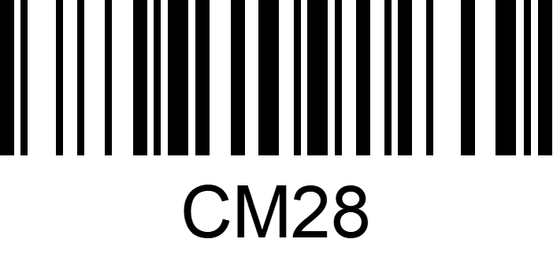
COMPANIES ACT 2004
(Section 219(1)(b)) (Regulation 45(2))

DIRECTOR'S CONTRACT TO TAKE SHARES OF COMPANY
AS QUALIFICATION SHARES

N$ 20,00 fee payable in terms of the Act and as set out in the regulations

Registration Number of Company

Name of company
I,
(full names of director)

hereby agree to take and pay for the following shares of the company, as qualification shares, in terms of article
 |  |  |  | of the company's articles of association.
Number of shares | Class of shares | Nominal par value  of share | Premium per share |  | Issue price of no par value share | Amount Paid
 |  |  |  |  | Total N$

Signed at |  | this |  | day | of |  | of the year

Signature _______________________
Director
Witness _________________________________________
Name in block capitals
Residential address
Email address

Signature ______________________
Witness

